**REST Assured in API Testing**

**REST Assured :-**

* It is a Java library or Java API for testing Restful Web Services.
* Can be also used for testing XML and JSON based Web Services.
* It Supports Post, Get, Put, Delete, etc.
* Can be integrated with testing frameworks like JUnit testing etc.
* REST Assured is implemented in Groovy.

**All the documentation’s and details of REST Assured are given in the link below :-**

<https://rest-assured.io/>

**Prerequisites:-**

* Java
* Eclipse
* Maven
* Testing

->Go to command prompt and check the java version

**Java -version**

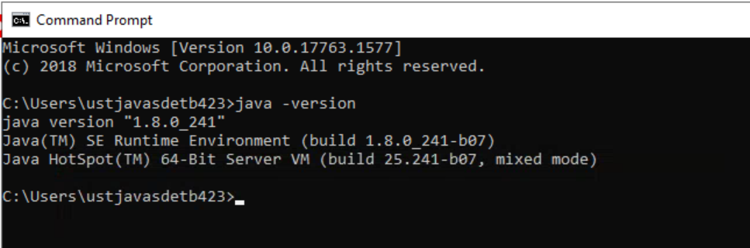

**Create project for API Testing**

->Open Eclipse

->Create a maven project called RestAssuredProject

**To add the dependencies refer the below link :-**

<https://mvnrepository.com/repos/central>

->Search for RSET Assured

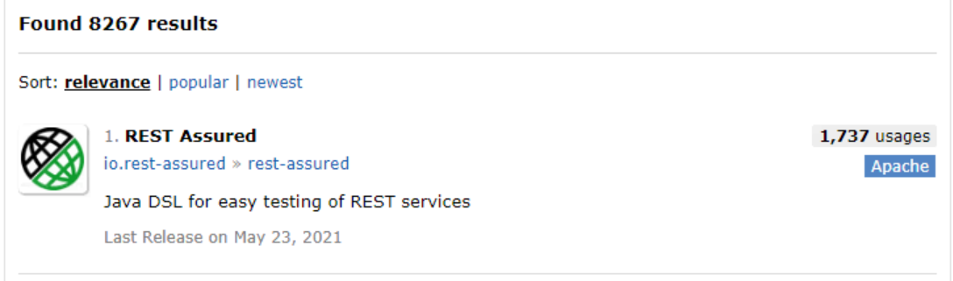

->Select the latest version

**<dependency>**

**<groupId>io.rest-assured</groupId>**

**<artifactId>rest-assured</artifactId>**

**<version>4.4.0</version>**

**<scope>test</scope>**

**</dependency>**

->Search for TestNG

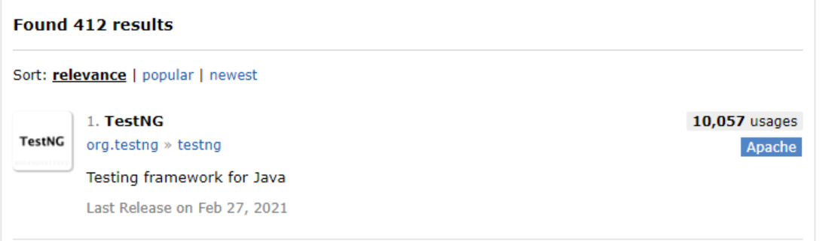

**<dependency>**

**<groupId>org.testng</groupId>**

**<artifactId>testng</artifactId>**

**<version>7.4.0</version>**

**<scope>test</scope>**

**</dependency>**

**For more dependencies or details :-**

**Go to rest assured site -> docs -> Getting started**

->Add dependencies in pom file

->Create a class in src/test/java

**GET Request 1**

**import** **static** io.restassured.RestAssured.given;

**import** **static** org.hamcrest.Matchers.*;

**import** org.testng.Assert;

**import** org.testng.annotations.Test;

**import** io.restassured.RestAssured;

**import** io.restassured.response.Response;

**public** **class** Test01_GET {

@Test

**public** **void** test() {

Response response = RestAssured.get("https://reqres.in/api/users?page=2");

System.***out***.println(response.statusCode());

System.***out***.println(response.asString());

System.***out***.println(response.getBody().asString());

System.***out***.println(response.statusLine());

**int** statusCode = response.getStatusCode();

Assert.assertEquals(statusCode, 200);

}

@Test

**public** **void** test1() {

given().get("https://reqres.in/api/users?page=2").then().statusCode(200).body("data.id[0]",equalTo(7));

}

}

**OUTPUTS :-**

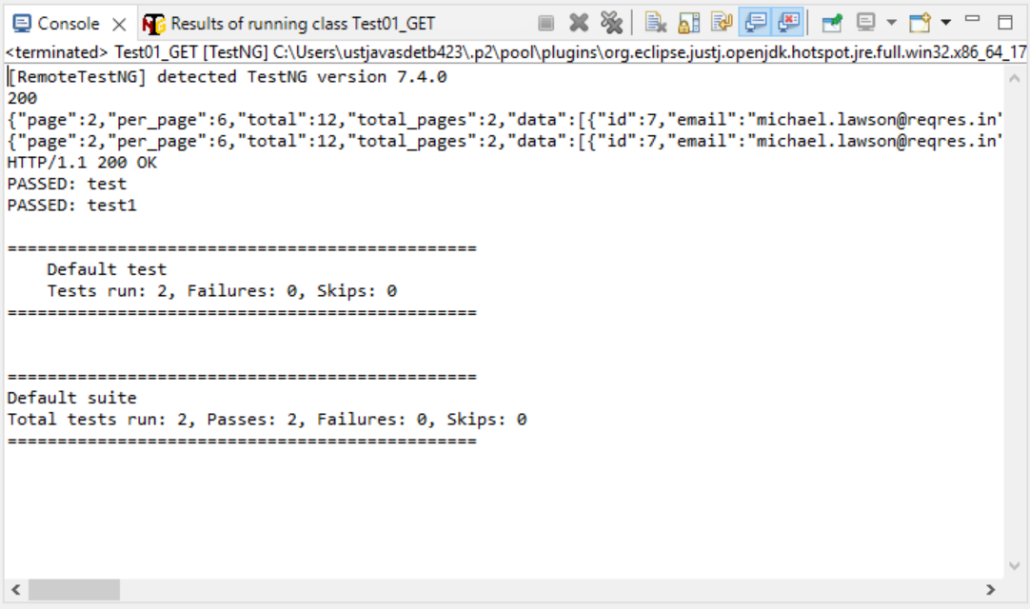

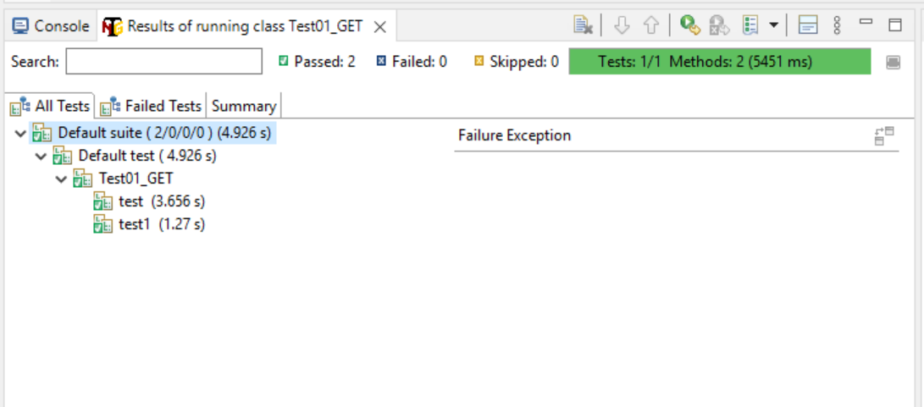

**GET Request 2**

**import** **static** io.restassured.RestAssured.given;

**import** **static** org.hamcrest.Matchers.equalTo;

**import** **static** org.hamcrest.Matchers.hasItems;

**import** org.testng.annotations.Test;

**public** **class** Test02_GET {

@Test

**public** **void** test1() {

given().get("https://reqres.in/api/users?page=2").then().

statusCode(200).

body("data.id[1]", equalTo(8)).

body("data.first_name", hasItems("Michael","Lindsay")).

log().all();

}

}

**OUTPUTS :-**

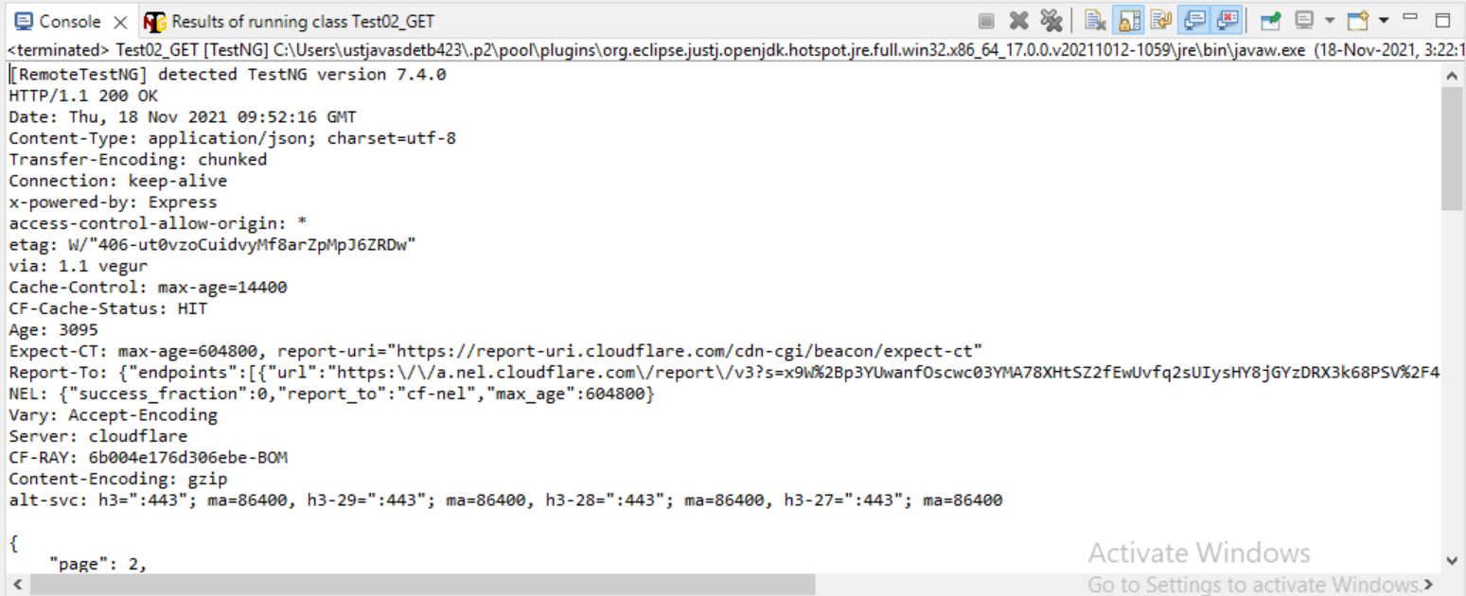

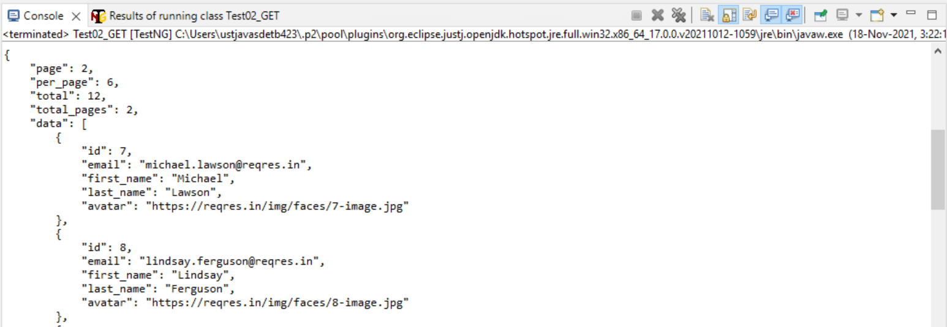

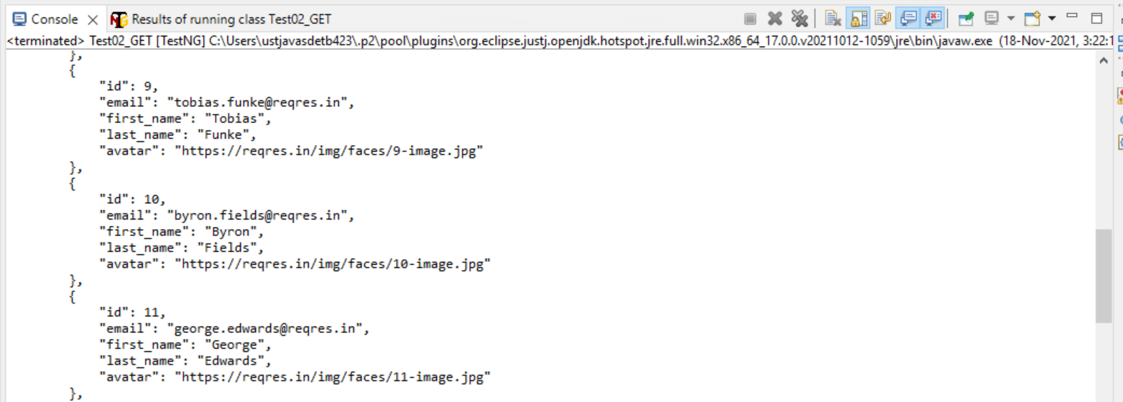

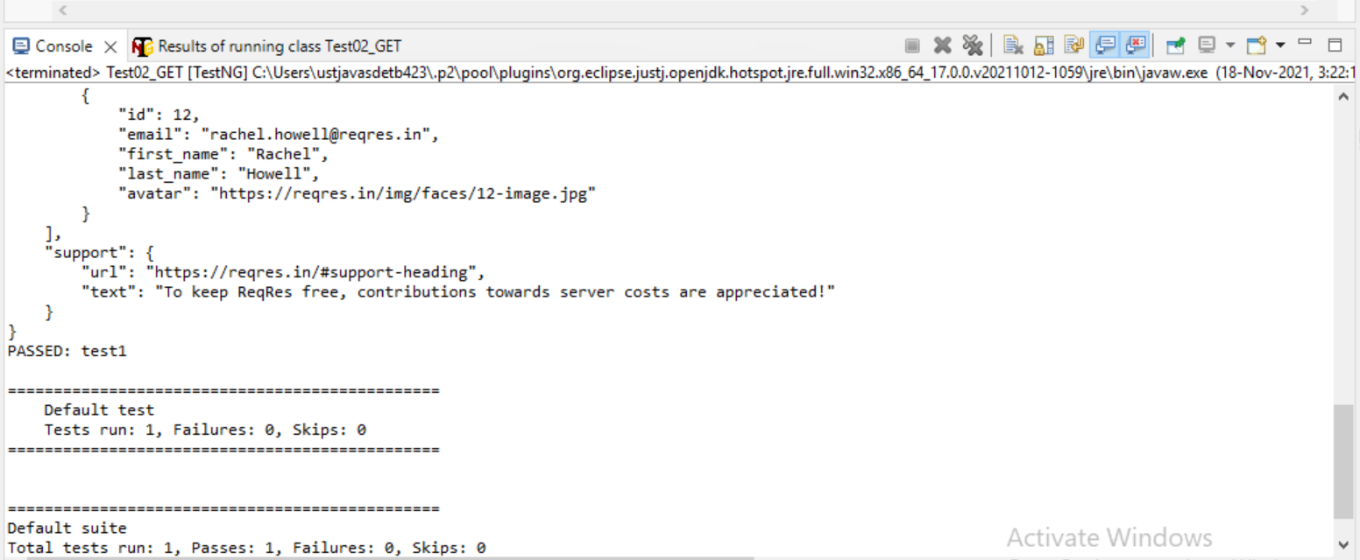

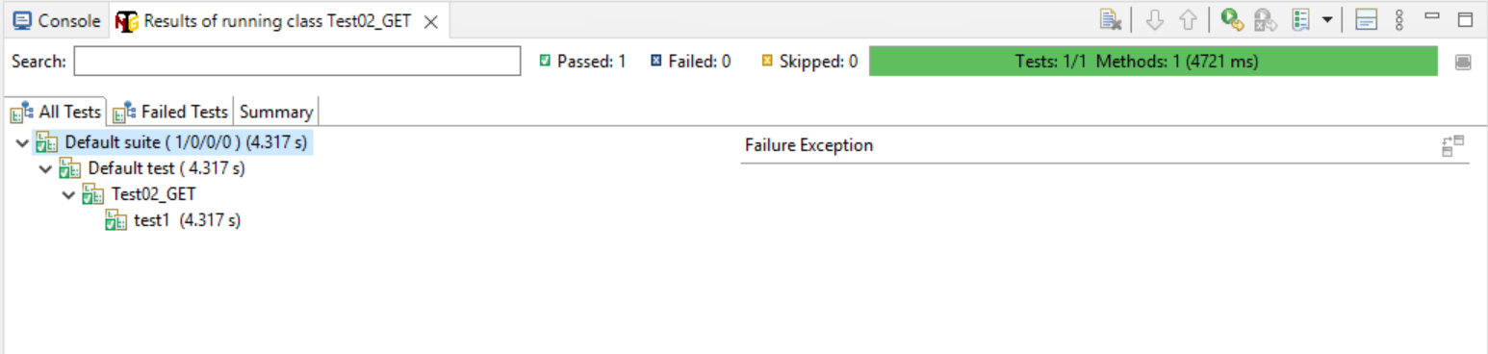

**POST**

JSON library (Other libraries : gson,jackson,json,Simple json)

<dependency>

<groupId>com.googlecode.json-simple</groupId>

<artifactId>json-simple</artifactId>

<version>1.1.1</version>

</dependency>

**POST Request**

**import** **static** io.restassured.RestAssured.given;

**import** org.json.simple.JSONObject;

**import** org.testng.annotations.Test;

**public** **class** Test01_POST {

@Test

**public** **void** test2() {

JSONObject request = **new** JSONObject();

request.put("name", "chaya");

request.put("job", "BA");

System.***out***.println(request);

System.***out***.println(request.toString());

given().

body(request.toJSONString()).

when().

post("https://reqres.in/api/users").

then().statusCode(201 );

}

}

**Outputs :-**

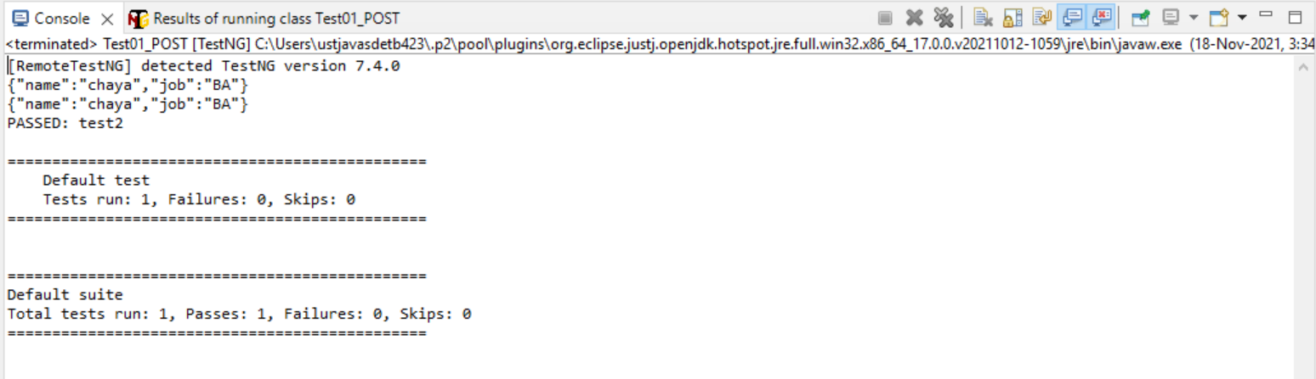

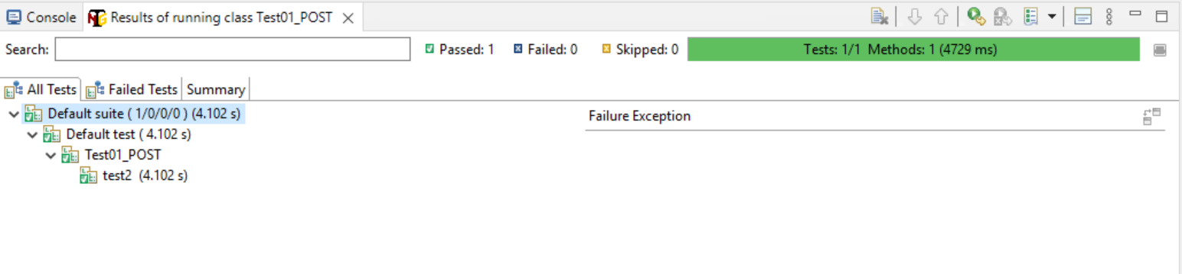

**PUT**

**PUT Request**

**import** **static** io.restassured.RestAssured.given;

**import** org.json.simple.JSONObject;

**import** org.testng.annotations.Test;

**public** **class** Test01_PUT {

@Test

**public** **void** test2() {

JSONObject request = **new** JSONObject();

request.put("name", "chaya");

request.put("job", "BAA");

System.***out***.println(request);

System.***out***.println(request.toString());

given().

body(request.toJSONString()).

when().

put("https://reqres.in/api/users/2").

then().statusCode(200);

}

}

**Outputs :-**

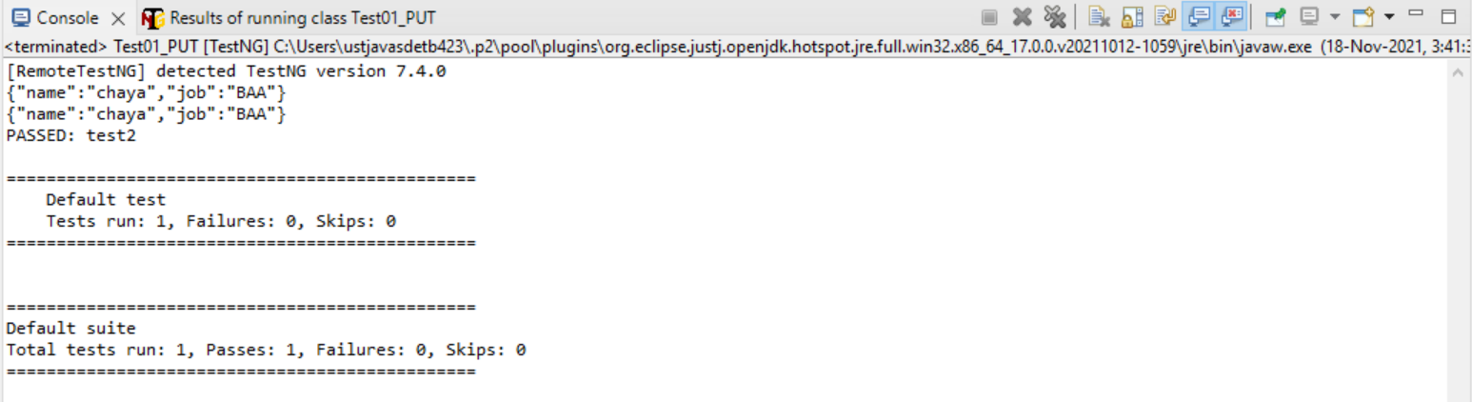

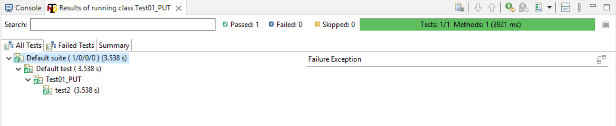

**PATCH**

**PATCH REQUEST**

**import** **static** io.restassured.RestAssured.given;

**import** org.json.simple.JSONObject;

**import** org.testng.annotations.Test;

**public** **class** Test01_PATCH {

@Test

**public** **void** test2() {

JSONObject request = **new** JSONObject();

request.put("name", "chaya");

request.put("job", "BAA");

System.***out***.println(request);

System.***out***.println(request.toString());

given().

body(request.toJSONString()).

when().

patch("https://reqres.in/api/users").

then().statusCode(200);

}

}

**Outputs :-**

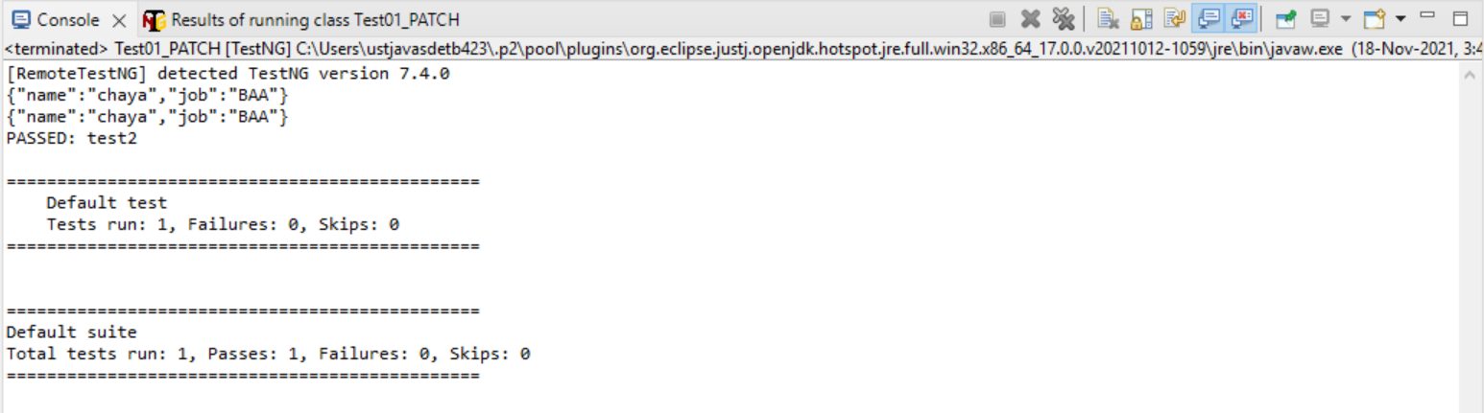

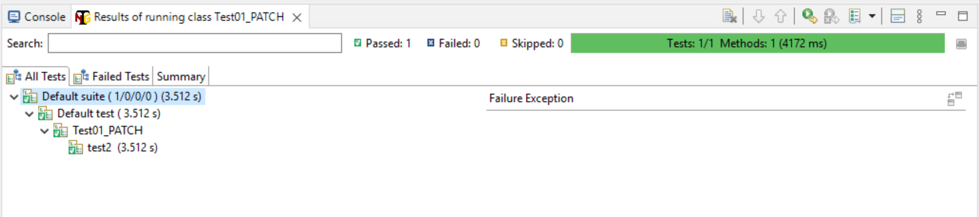

**DELETE**

**DELETE REQUEST**

**import** **static** io.restassured.RestAssured.given;

**import** org.json.simple.JSONObject;

**import** org.testng.annotations.Test;

**public** **class** Test05_Delete {

@Test

**public** **void** test3() {

JSONObject request = **new** JSONObject();

given().

body(request.toJSONString()).

when().

delete("https://reqres.in/api/users/2").

then().statusCode(204).

log().all();

}

}

**Outputs :-**

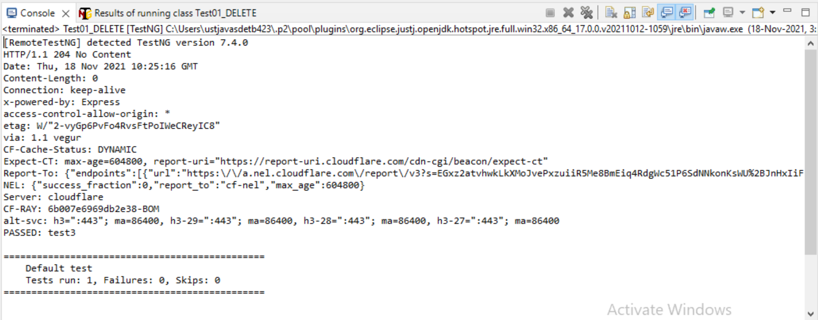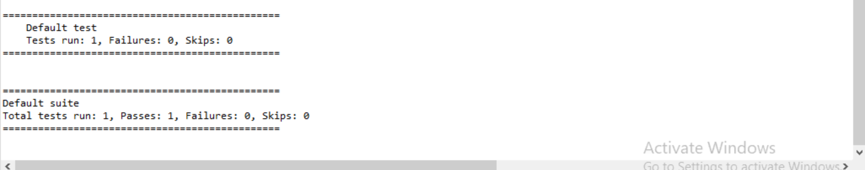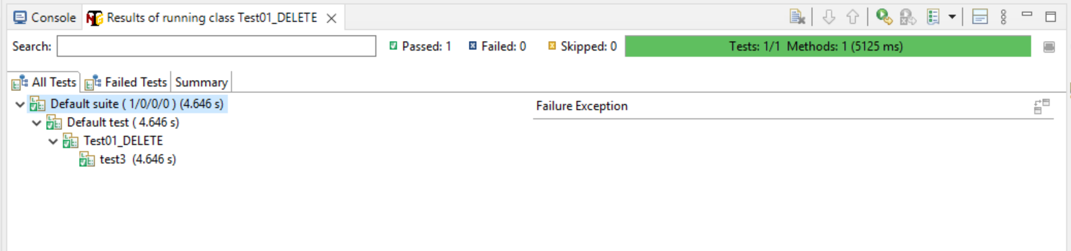

**Verify Status Codes**

**import** org.testng.Assert;

**import** org.testng.annotations.Test;

**import** io.restassured.RestAssured;

**import** io.restassured.response.Response;

**import** io.restassured.specification.RequestSpecification;

**public** **class** VerifyStatusCode {

@Test

**public** **void** verify_statusCode()

{

String url ="https://reqres.in/api/users?page=2";

RequestSpecification http_request = RestAssured.given();

Response response = http_request.get(url);

**int** statusCode = response.getStatusCode();

System.***out***.println("Print Status Code---->"+statusCode);

Assert.assertEquals(statusCode,200,"Status Code are Matched");

}

}

**Outputs :-**

